Macroeconomic Equilibrium

Topic 1: Real output and price level

Difficulty Level 2
- An increase in government spending will most likely cause the price level and real gross domestic product to change in which of the following ways?
Price Level Real Gross Domestic Product
  - Increase Increase
  - Increase Decrease
  - Increase Not change
  - Decrease Increase
  - Decrease Decrease
- If businesses grow more optimistic and increase their purchases of physical capital, how will the price level and real gross domestic product likely change?
Price Level Real Gross Domestic Product
  - Increase Increase
  - Increase Decrease
  - Increase Not change
  - Decrease Increase
  - Decrease Not change
- An increase in personal income taxes will most likely cause the price level and real gross domestic product to change in which of the following ways?
Price Level Real Gross Domestic Product
  - Increase Increase
  - Decrease Decrease
  - Increase Decrease
  - Decrease Increase
  - Decrease Not change
Use the graph below to answer the following question.
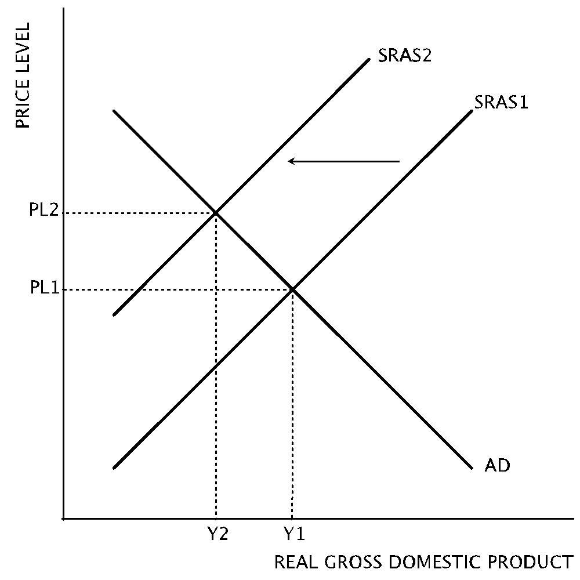
- Which of the following likely caused the change represented in the graph?
  - an increase in the money supply
  - an increase in the price of imported oil
  - a decrease in the price of imported oil
  - an increase in personal income taxes
  - a decrease in nominal interest rates
- If an increase in aggregate supply is followed by a decrease in aggregage demand, which of the following will necessarily occur?
  - The price level will increase.
  - The price level will decrease.
  - Output will increase.
  - Output will not change.
  - Output will decrease.
- Stagflation may result from which of the following changes?
  - A positive demand shock
  - A negative demand shock
  - A positive supply shock
  - A negative supply shock
  - A positive supply shock and a negative demand shock
- An increase in net exports will likely result in
  - increasing aggregate output and a decrease in price level
  - a decrease in the unemployment rate
  - no change in aggregate output and price level
  - a decrease in short-run aggregate supply
  - an increase in the price level and unemployment rate

Difficulty Level 3
- Suppose the aggregate price level is increasing and the equilibrium level of aggregate output is decreasing. An increase in which of the following most likely caused these changes?
  - Industrial production
  - Government defense spending
  - Nominal wages
  - The corporate tax rate
  - Worker productivity
- An unanticipated decrease in aggregate output and price level when the economy is in equilibrium will result in
  - an increase in unplanned inventories
  - an increase in nominal interest rates
  - a decrease in unemployment
  - a decrease in the money supply
  - a decrease in aggregate supply
Use the graph below to answer the following question.
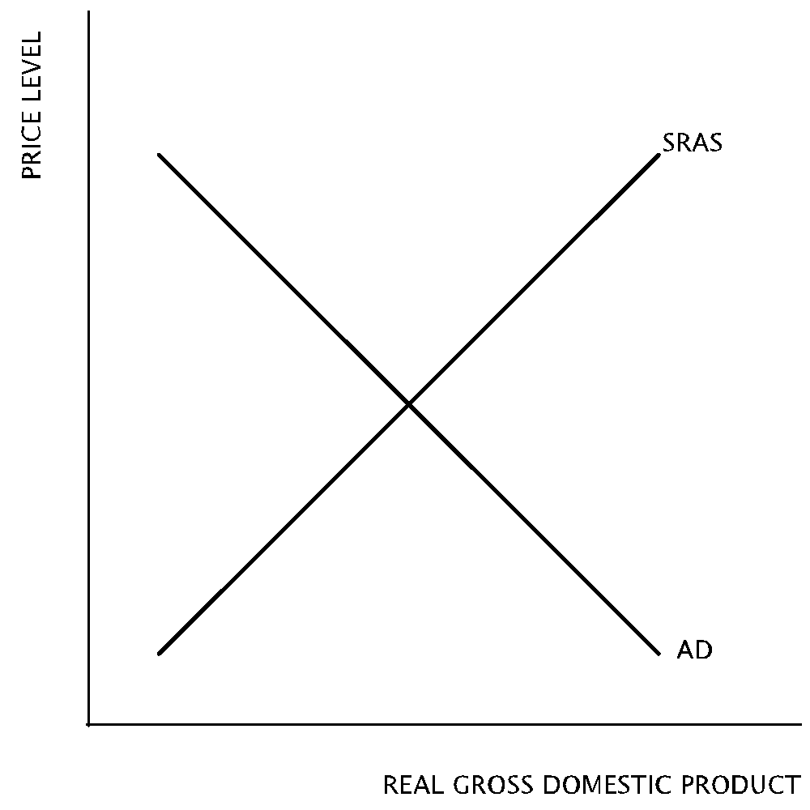
- According to the graph, which of the following will necessarily result in an increase in output?
- A rightward shift of the aggregated demand curve
- A rightward shift of the short-run aggregate supply curve
- A leftward shift of the aggregate demand curve
- A leftward shift of the short-run aggregate supply curve
  - I only
  - II only
  - I and II only
  - II and III only
  - I and IV only

Topic 2: Short and long run

Difficulty Level 2
Use the graph below to answer the following question.
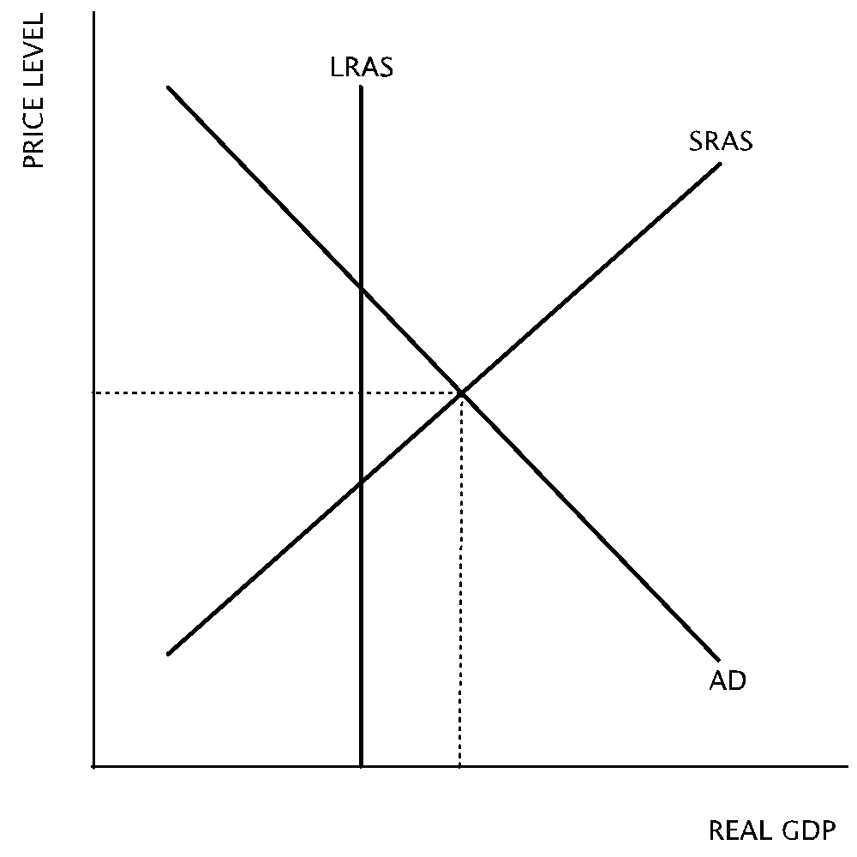
- According to the graph, which of the following statements about the long-run equilibrium of the economy depicted is true?
  - The economy will remain in a recession without an expansionary monetary policy.
  - The short-run aggregate supply curve will shift to the left to restore long-run equilibrium when nominal wages increase.
  - The economy is in long-run equilibrium.
  - The unemployment rate will decrease as the economy is restored to long-run equilibrium.
  - The aggregate demand curve will shift to the left to restore long-run equilibrium.

Difficulty Level 3
Use the graph below to answer the following question.
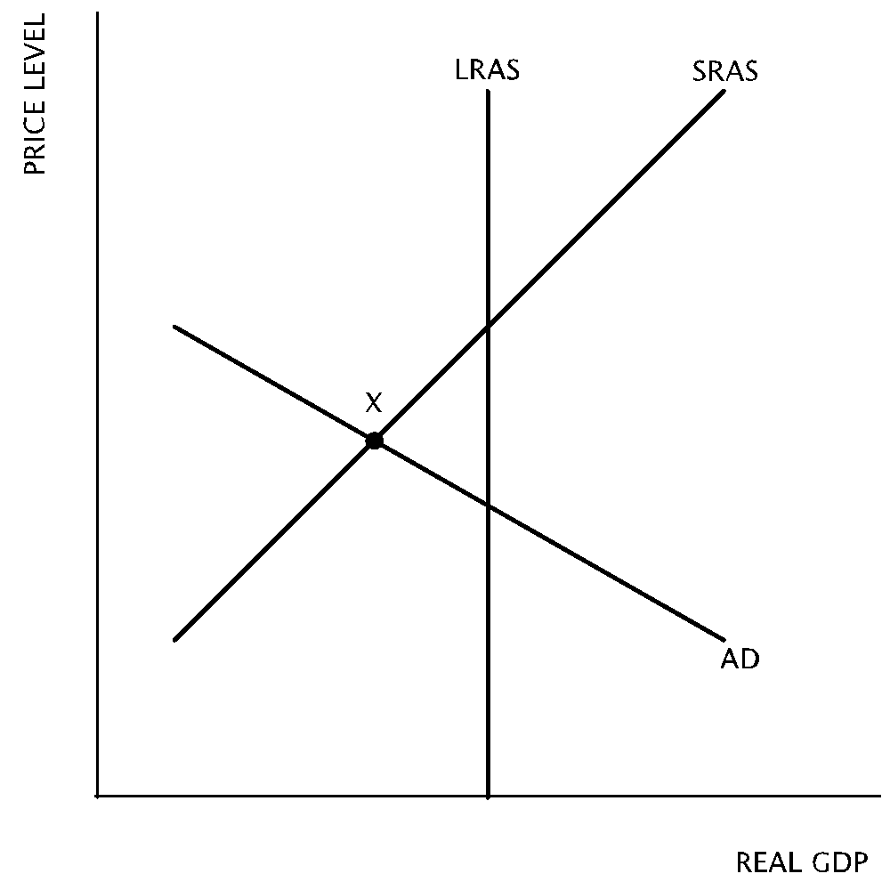
- If no fiscal or monetary policy is used to address the state of this economy, how will it change in the long-run?
  - As nominal wages increase aggregate demand will shift to right to restore long-run equilibrium
  - As nominal wages increase short-run aggregate supply will shift to the right to restore long-run equilibrium
  - As nominal wages decrease short-run aggregate supply will shift to the right to restore long-run equilibrium
  - As nominal wages decrease long-run aggregate supply will shift to the left to restore long-run equilibrium
  - No changes will occur
- If an economy is currently producing at the full-employment level of output, what will be the effect on the unemployment rate of an increase in the value of the stock market in the short-run and in the long-run?
Short-run Long-run
  - Increase No change
  - Increase Increase
  - Decrease Decrease
  - Decrease No change
  - Increase Decrease
Use the graph below to answer the following question.
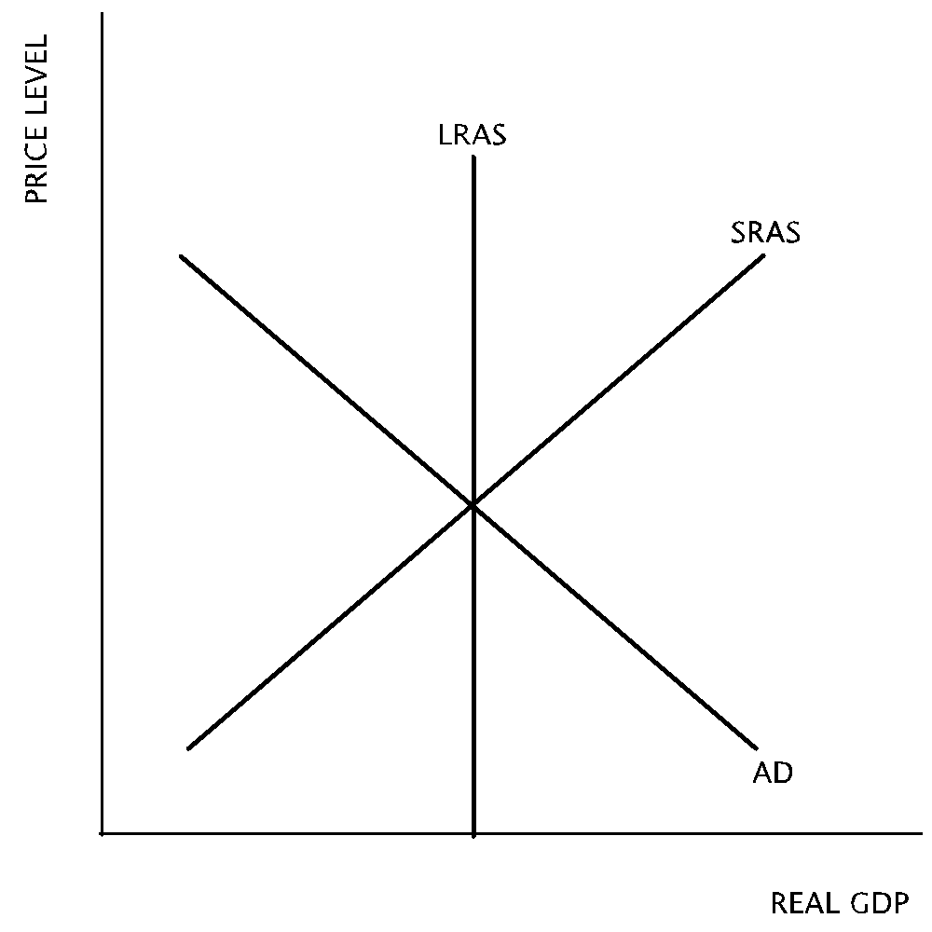
- In the economy depicted in the graph, what will result in the long-run if the government doubles its spending on health care.
Output Price level
  - Increase No change
  - No change Increase
  - Decrease No change
  - No change Decrease
  - No change No change

Topic 3: Actual v. full employment output

Difficulty Level 2
- When an economy is in recession, the actual unemployment rate is
  - equal to the unemployment rate at full employment output
  - less than the natural rate of unemployment
  - more than the natural rate of unemployment
  - equal to the natural rate of unemployment
  - more than 8 percent
Use the graph below to answer the following question.
- According to the graph, which of the following statements about the unemployment rate is true?
  - Cyclical, frictional, and structural unemployment exist.
  - The unemployment rate is above the natural rate of unemployment.
  - The economy is producing above full employment output.
  - The unemployment rate is equal to the cyclical rate.
  - The economy is producing at full employment output.

Topic 4: Business cycle and economic fluctuations

Difficulty Level 2
Use the following graph to answer the question below.
- According to the graph, if the economy is at point X, there is
  - long-run equilibrium with full employment.
  - a recessionary gap with high unemployment.
  - an inflationary gap with low unemployment.
  - an inflationary gap with high unemployment.
  - a recessionary gap with low unemployment.
- Which of the following statements is true about a recessionary gap?
  - The unemployment rate is below the natural rate of unemployment
  - Aggregate output is below potential output
  - Potential output is below aggregate output
  - Aggregate output is above potential output
  - The economy is experiencing full employment
- Assuming the economy is in long-run equilibrium, which of the following changes will create an inflationary gap?
- An increase in the wealth of households.
- An decrease in the supply of imported oil.
- An increase in government spending.
  - I only
  - II only
  - III only
  - I and III only
  - II and III only
Macroeconomic Equilibrium
1 | A | 6 | D | 11 | B | 16 | E
2 | A | 7 | B | 12 | C | 17 | B
3 | B | 8 | C | 13 | D | 18 | B
4 | B | 9 | A | 14 | B | 19 | D
5 | B | 10 | C | 15 | C

